SP.248 Preparation Assignment: Ill-Structured Problems

The Importance of Addressing Ill-Structured Problems
Demand is increasing for people able to address ill-structured problems, especially on a global level¹, and for science, technology, engineering, and mathematics (STEM) professions in the US in particular². The importance of cultivating this ability has been recognized by various organizations, be it for society³ and for the economy⁴, or for formal education⁵ and more specifically for engineering higher education⁶.

What are Ill-Structured Problems?
An ill-structured (or ill-defined) problem is authentic (does or could exist in the real world), multidisciplinary, and complex, including multiple components and interrelationships. As Figure 1 shows, problems can be placed on a spectrum based on their structuredness, or the degree of knowledge regarding the (a) problematic state, (b) acceptable state(s), and (c) potentially effective approaches for bridging those states. Ill-structured problems normally have multiple potential solutions, whereas well-structured problems have fewer solutions⁷.
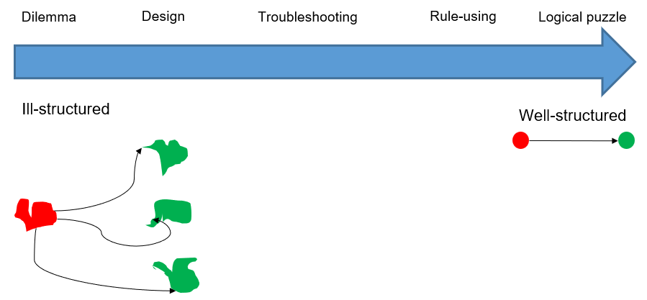
Figure 1. The problem structuredness spectrum. Adapted from Jonassen (2000). Red: problematic state; Green: acceptable state; arrow: way for getting from problematic to acceptable state.

Figure 2 shows examples for five types of problems with varying degrees of structuredness.
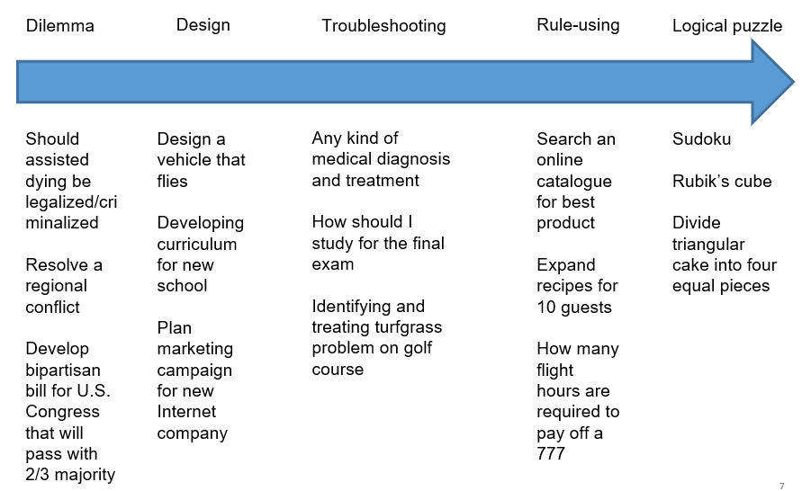
Figure 2. Examples of problems with different degrees of structuredness. Adapted from Jonassen (2000). The arrow depicts an increase in problem structuredness.

How can we Address Ill-Structured Problems?
Addressing ill-structured problems is an iterative process in which the initially vague conception of the problem is made clearer. This process results in the creation of artifacts (physical or digital). Solutions to ill-structured problems are not ‘correct’ or ‘incorrect’, but rather are ‘better’ or ‘worse’ when compared with each other. The value of a solution to an ill-structured problem depends on inter-subjective success criteria agreed upon by a particular group, such as the problems’ stakeholders.

It stands to reason that the first step in addressing an ill-structured problem effectively would be to structure it. Once the problem has been structured, or defined, we can generate solutions for the problem based on the specific context, resources at our disposal, the disciplines involved, and so on. Table 1 summarizes a method for structuring ill-structured problems, called DIMES: Describe, Inquire, Model, Extract, State. Note that the process of addressing ill-structured problems is nearly always iterative, moving back and forth between stages, even though the method is presented as linear.
Table 1. The DIMES method for structuring ill-structured problems.
Stage | Activity | Product
1. Describe | Describe the problem in a brief and unstructured way, using plain language. | Problem description
2. Inquire | Inquire into the problem as a researcher, based on the five Ws of who, what, where, when, and why. | Case description
3. Model | Based on the case description, model the problem as a conceptual hierarchy of objects, processes, and functions. | Conceptual hierarchical model
4. Extract | Extract leverage points (high impact-to-cost ratio), i.e., objects, processes, or functions deep within the model with which one could have a substantial impact on the problem with relatively little effort. | List of leverage points
5. State | State the problem concisely and in a solution-neutral way based on the answers to the five Ws from the case description and on the list of leverage points & data analysis insights. | Problem statement

References
- Nedelkoska, L., & Quintini, G. (2018). Automation, skills use and training.
- Jang, H. (2016). Identifying 21st century STEM competencies using workplace data. Journal of Science Education and Technology, 25(2), 284–301.
- Scott, C. L. (2015). The futures of learning 2: What kind of learning for the 21st century. UNESCO Education Research and Foresight. Paris, France.
- World economic forum, the future of jobs: Employment, skills and workforce strategy for the fourth industrial revolution, in Global Challenge Insight Report, World Econ. Forum, Geneva, Switzerland, 2016.
- National Research Council. (2013). Education for life and work: Developing transferable knowledge and skills in the 21st century. Washington, DC: National Academies Press.
- ABET. (2021). General criterion 3. Student outcomes from criteria for Accrediting Engineering Programs, 2021–2022.
- D. H. Jonassen, “Toward a design theory of problem solving,” Educ. Technol. Res. Develop., vol. 48, no. 4, pp. 63–85, 2000.

MIT OpenCourseWare
https://ocw.mit.edu/

SP.248 The NEET Experience
Fall 2025

For information about citing these materials or our Terms of Use, visit: https://ocw.mit.edu/terms.

