Preparation Assignment 3: Creative thinking - instructor solution

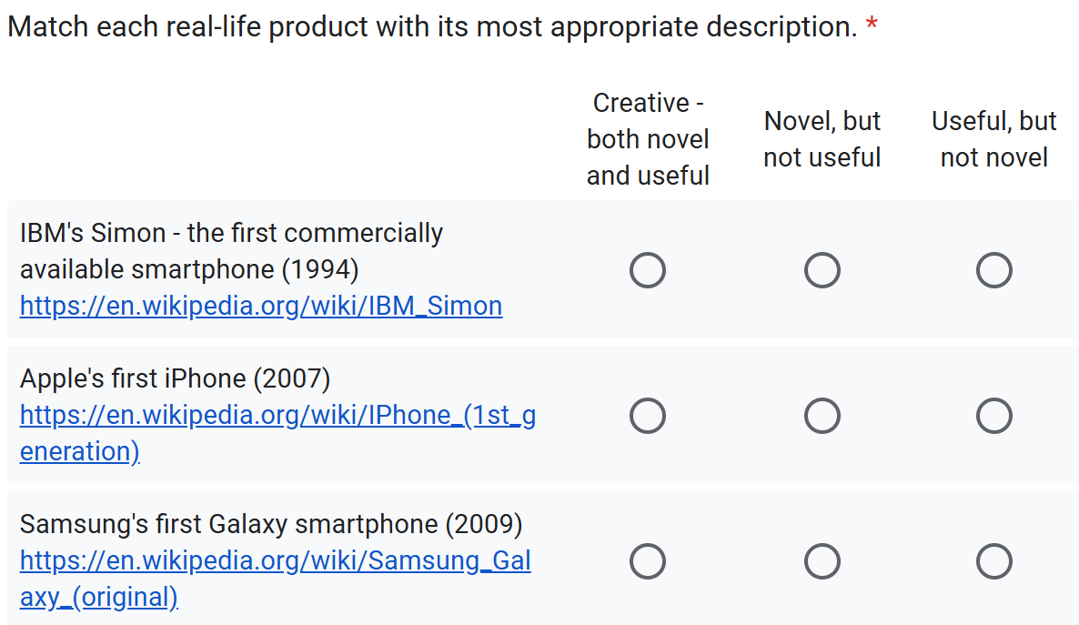
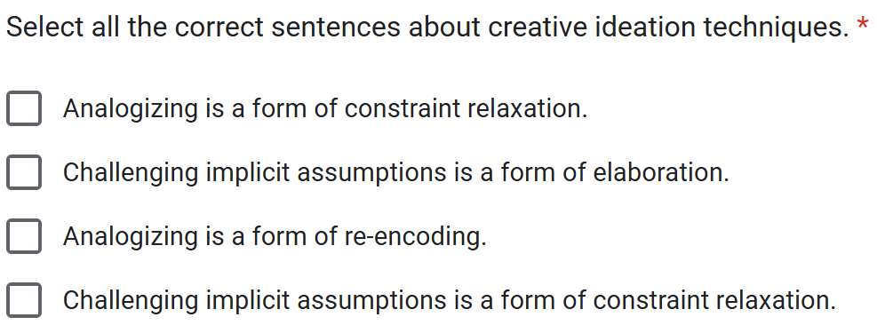

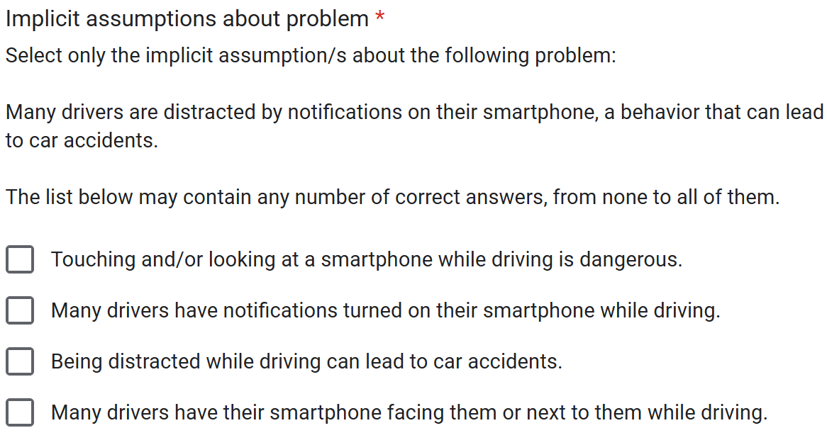

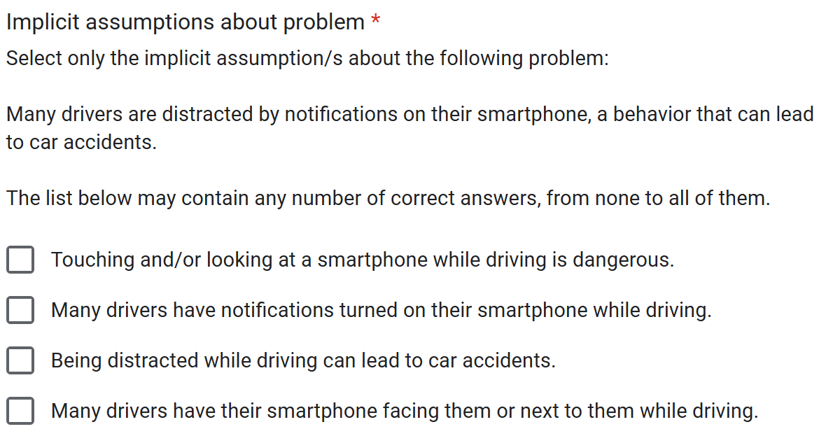

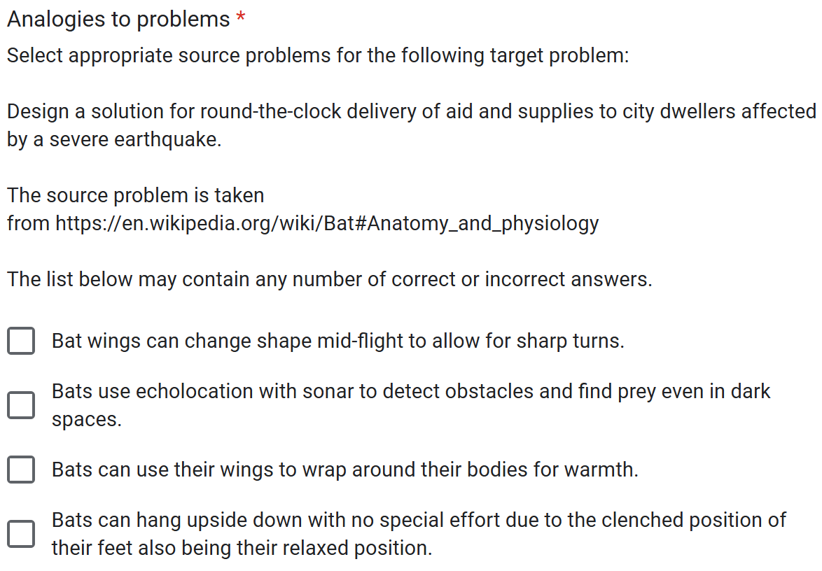

MIT OpenCourseWare
https://ocw.mit.edu/

SP.248 The NEET Experience
Fall 2025

For information about citing these materials or our Terms of Use, visit: https://ocw.mit.edu/terms.

