Preparation2 Article: Systems Thinking

Author: Rea Lavi

The Need for Systems Thinkers in Engineering
As systems are becoming more interconnected and complex, demand for engineers who possess systems thinking is also increasing¹. The US National Research Council² presented a framework for 21st century skills in science and engineering education—primary, secondary, and higher—which included systems thinking. Additionally, the ABET³ 2025-2026 criterion 3 (student outcomes) for accrediting engineering programs mentions students must have the ability to produce engineering solutions while considering factors which require a systems perspective, namely global, cultural, social, environmental, and economic factors. Another testament of the need for system thinkers is that critically important skills for science, technology, engineering, and mathematics (STEM) disciplines, taken from the US Labor Department database⁴, include systems analysis and systems evaluation.

What is a Technological (engineered) System?
While the definition of system is a subject of rich, ongoing academic debate⁵, for the purposes of this class, we define a technological system, or system for short, as follows: a system is an entity composed of interacting parts. This entity delivers a predetermined function through its architecture, which is a combination of its structure and its behavior. The system’s function is realized through interactions of the system parts, both internally and with the system’s environment; these interactions can be explained by cause-and-effect relationships. Some whole-system properties vary from those of its individual parts. The purpose of a system is to deliver a predetermined benefit to specific group/s of humans—the system’s beneficiaries. The system’s purpose is achieved through its function^{1,6-9}.

What is Systems Thinking in Engineering?
Systems thinking is a higher-order thinking skill or set of skills which enable the identification, understanding, prediction, and improvement of every aspect of a technological system: purpose, function, structure, and behavior, and the way these aspects interrelate within the system^{1,6-7}.

The SAFO Framework: Systems Thinking for Technological Systems
The system architecture-function-outcome (SAFO) framework was designed for introducing first-year engineering students to systems thinking about technological systems in any domain. SAFO captures the definition of ‘system’ given above. Initial validations of the framework have been published in peer-reviewed works¹⁰.
The framework uses distinct terms for the parts of a system (structure) and the relations & interactions between those parts (behavior). This allows for making clear distinctions between static and dynamic parts of a technological system⁷.
SAFO also distinguishes between a system’s function and its outcome (similar to purpose), both emergent aspects of technological systems. While function represents the interaction of the system (as a whole) with other entities or systems (technological or otherwise) in its immediate environment, outcome represents the effect of the system function on people. The system outcome in SAFO includes the problem being solved by the system’s intended function as well as the group/s of people affected by it, thus explicitly including the human element in the description of a technological system.
SAFO’s simplicity, coupled with its capturing of the essential aspects of technological systems, allows for the description and improvement of technological systems and for the assessment of conceptual understanding and of personal attitudes concerning these systems. It should be noted that as an introductory framework meant for first-year engineering students, the SAFO framework does not address attributes of system complexity¹¹.
Figure 1 shows the aspects and components which comprise the SAFO framework for technological systems.

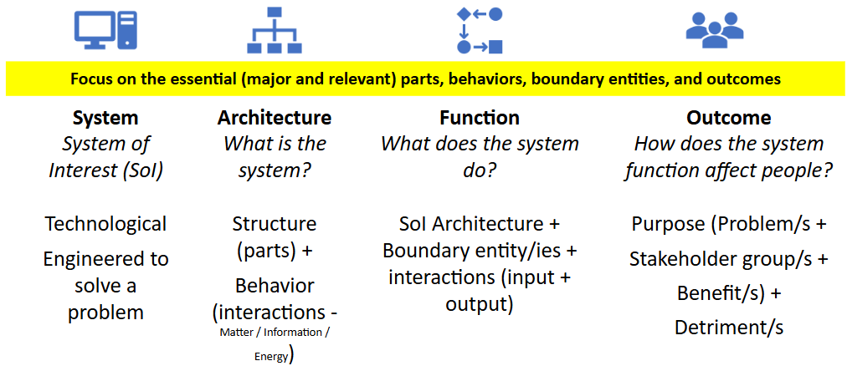
** Boundary systems do not have to be technological.

Figure 1. The System Architecture-Function-Outcome framework overview.

Figures 2 and 3 describe a bicycle using the SAFO framework.

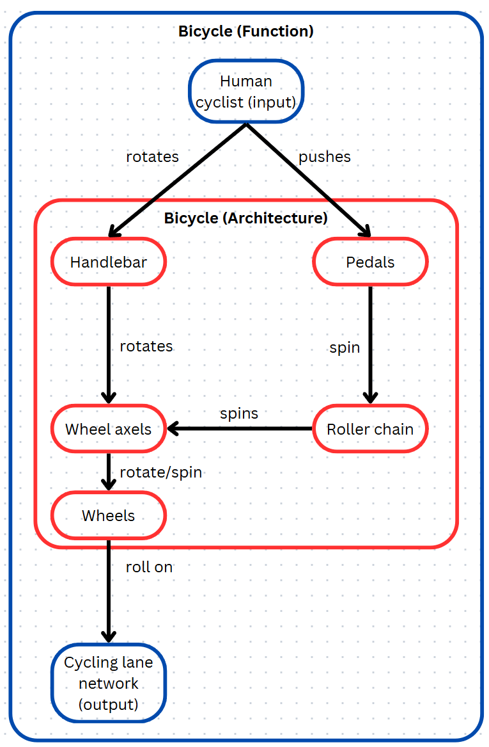
Wheel rolls on Road Network
Increased risk to pedestrians on pavements
Figure 2. The System Architecture-Function-Outcome framework applied to a bicycle, showing the system’s architecture and function. Red borders: system of interest. Blue borders: boundary system.

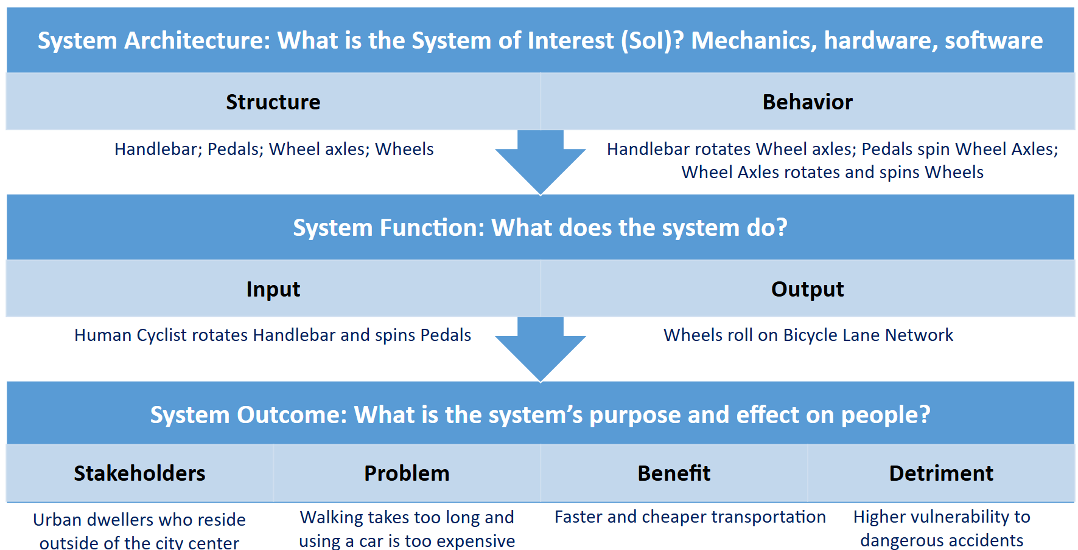
Figure 3. The System Architecture-Function-Outcome framework template applied to a bicycle. Red font: system of interest. Blue font: boundary system.

References
- E. Crawley, B. Cameron and D. Selva, System Architecture: Strategy and Product Development for Complex Systems, Pearson Higher Education, Hoboken, pp. 8-34, 2015.
- National Research Council, Education for Life and Work: Developing Transferable Knowledge and Skills in the 21st Century, National Academies Press, Washington, DC, 2013.
- ABET, Criterion 3. Student outcomes from criteria for Accrediting Engineering Programs, 2025–2026, 2025.
- H. Jang, Identifying 21st century STEM competencies using workplace data, Journal of Science Education and Technology, 25(2), pp. 284–301, 2016.
- D. Dori, H. Sillitoe, R. M. Griego, D. McKinney, E. P. Arnold, P. Godfrey, ... and D., Krob, System definition, system worldviews, and systemness characteristics, IEEE Systems Journal, 14(2), pp. 1538-1548, 2019.
- R. D. Arnold and J. P. Wade, A definition of systems thinking: A systems approach, Procedia Computer Science, 44, pp. 669-678, 2015.
- D. Dori, Model-Based Systems Engineering with OPM and SysML, Springer, New York, pp. 3-395, 2016.
- INCOSE, Most general “System” definition, https://www.incose.org/about-systems-engineering/system-and-se-definition/system-and-se-definitions, Accessed 1 July 2022.
- P. N. Whitehead, W. T. Scherer and M. C. Smith, Systems thinking about systems thinking a proposal for a common language, IEEE Systems Journal, 9(4), pp. 1117-1128, 2015.
- Lavi, R., & Bertel, L. B. (2024). The System Architecture-Function-Outcome framework for fostering and assessing systems thinking in first-year STEM education and its potential applications in case-based learning. Education Sciences, 14(7), 720.
- S. A. Sheard and A. Mostashari, Principles of complex systems for systems engineering, Systems Engineering, 12(4), pp. 295-311, 2009.

MIT OpenCourseWare
https://ocw.mit.edu/

SP.248 The NEET Experience
Fall 2025

For information about citing these materials or our Terms of Use, visit: https://ocw.mit.edu/terms.

