Preparation1 Article: Algorithmic Thinking

The Need for Algorithmic Thinking
Computational technologies are the heart of the new industrial era, also called Industry 4.0, or the Fourth Industrial Revolution. In this era, computational thinking has become more important than ever (Sondakh et al., 2020). Accordingly, the World Economic Forum (2020) has identified the following skills, all related to computational thinking, as being in the top 15 most important skills for the global job market: analytical thinking and innovation, technology design and programming, critical thinking and analysis, complex problem-solving, and system analysis and evaluation.
Computational thinking is an activity and thought process involved mostly in problem solving, involving abstraction, decomposition, algorithmic thinking, evaluation, generalization, automation, and debugging (Selby & Woollard, 2013; Sondakh et al., 2020).
In SP.248 and in this document, we will focus specifically on algorithmic thinking as a component or skill of computational thinking.
Algorithmic Thinking
Algorithmic thinking is the skill of formulating step-by-step instructions to solve problems. This skill can be said to include the following constructs:

- Procedural thinking—the identification, selection, and execution of appropriate steps to solve problems.
- Sequence action—the ability to create a set of precise and correct steps to solve problems, using explicit wording.
- Conditional thinking—the ability to make a decision based on certain conditions and create options of solutions.
- Repetition—using the same instruction iteratively.
- Parallelism—the execution of more than one instructions simultaneously.
- Logical reasoning—the ability to do reasoning and inferring conclusion based on existing knowledge (Sondakh et al., 2020).

Types of Algorithmic Operations
Algorithmic operations can be placed on a spectrum of complexity, from sequential operations on the simplest end, through iterative, conditional, or nested-sequential operations, to nested iterative or nested conditional, etc., operations on the most complex end. Figures 1-4 shows examples taken from Scratch for four fundamental types of operations: sequential (Figure 1), conditional (Figure 2), iterative (Figure 3) (Tsukamoto et al., 2022), and nested (Figure 4). An algorithmic operation can be any one of these types or any combination thereof. A nested operation may include any other type/s of operation/s.
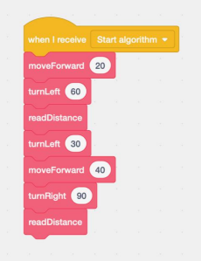
Figure 1. Sequential algorithmic operation.

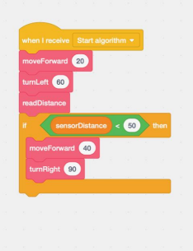Figure 2. Conditional algorithmic operation.
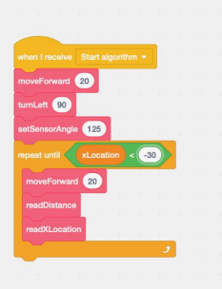Figure 3. Iterative algorithmic operation.
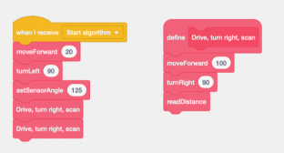
Figure 4. Nested operation (sequential operation within sequential operation)

References

- Selby, C., & Woollard, J. (2013). Computational thinking: the developing definition.
- Sondakh, D. E., Osman, K., & Zainudin, S. (2020). A Proposal for holistic assessment of computational thinking for undergraduate: Content validity. European Journal of Educational Research, 9(1), 33-50.
- Tsukamoto, H., Oomori, Y., Nagumo, H., Takemura, Y., Monden, A., & Matsumoto, K. I. (2017, October). Evaluating algorithmic thinking ability of primary schoolchildren who learn computer programming. In 2017 IEEE Frontiers in Education Conference (FIE) (pp. 1-8). IEEE.
- World Economic Forum (2020). The future of jobs report 2020. Retrieved from Geneva.

MIT OpenCourseWare
https://ocw.mit.edu/

SP.248 The NEET Experience
Fall 2025

For information about citing these materials or our Terms of Use, visit: https://ocw.mit.edu/terms.

https://scratch.mit.edu/

